**Name : Aditi Sant , AI&DS-B1 batch , Roll no.: 23211**

EXPERIMENT NO: 8

#include <iostream>

using namespace std;

struct SLLNode *createSLL(int cnt, struct SLLNode *head);

void displaySLL(struct SLLNode *head);

void A_U_B();

void A_int_B();

void A_Min_B();

void B_Min_A();

void U_Min_A_U_B();

struct SLLNode

{

char data;

struct SLLNode *next;

} *headU, *headA, *headB;

int main()

{

cout<<"Name : Aditi Sant , AI&DS-B1 batch , Roll no.: 23211"<<endl;

int i, no;

cout << "\n\n\t How many Linked Lists: ";

cin >> no;

headU = headA = headB = NULL;

for (i = 1; i <= no; i++)

{

if (i == 1)

{

cout << "\n\n\t Enter 10 Students of SE Comp : \n";

headU = createSLL(10, headU);

cout << "\n";

displaySLL(headU);

}

if (i == 2)

{

cout << "\n\n\t Enter 5 Students who like Vanilla Icecreme: \n";

headA = createSLL(5, headA);

cout << "\n";

displaySLL(headA);

}

if (i == 3)

{

cout << "\n\n\t Enter 5 Students who like Butterscotch Icecreme: \n";

headB = createSLL(5, headB);

cout << "\n";

displaySLL(headB);

}

}

cout << "\n\n Input Sets:------------------------";

cout << "\n\n Set 'U': ";

displaySLL(headU);

cout << "\n\n Set 'A': ";

displaySLL(headA);

cout << "\n\n Set 'B': ";

displaySLL(headB);

cout << "\n\n Output Sets:------------------------";

A_U_B();

A_int_B();

A_Min_B();

B_Min_A();

U_Min_A_U_B();

cout << "\n\n";

return 0;

}

struct SLLNode *createSLL(int cnt, struct SLLNode *head)

{

int i;

struct SLLNode *p, *newNode;

for (i = 0; i < cnt; i++)

{

newNode = new (struct SLLNode);

cout << "\t Enter Student Initial: ";

cin >> newNode->data;

newNode->next = NULL;

if (head == NULL)

{

head = newNode;

p = head;

}

else

{

p->next = newNode;

p = p->next;

}

}

return head;

}

void displaySLL(struct SLLNode *head)

{

cout<<"\t";

struct SLLNode *p;

p = head;

while (p != NULL)

{

cout << " " << p->data;

p = p->next;

}

}

void A_U_B()

{

int i, j;

char a[10];

struct SLLNode *p, *q;

i = 0;

// Index of Resultant Array

p = headA;

// pointer to Set 'A'

q = headB; // pointer to Set 'B'

while (p != NULL && q != NULL)

{

if (p->data == q->data)

{

a[i] = p->data;

i++;

p = p->next;

q = q->next;

}

else

{

a[i] = p->data;

i++;

p = p->next;

}

}

if (p == NULL)

{

while (q != NULL)

{

a[i] = q->data;

i++;

q = q->next;

}

}

if (q == NULL)

{

while (p != NULL)

{

a[i] = p->data;

i++;

p = p->next;

}

}

cout << "\n\n\t Set A U B: ";

for (j = 0; j < i; j++)

cout << " " << a[j];

}

void A_int_B()

{

int i, j;

char a[10];

struct SLLNode *p, *q;

i = 0;

p = headA;

while (p != NULL)

{

q = headB; // pointer to Set 'B'

while (q != NULL)

{

if (p->data == q->data)

{

a[i] = p->data;

i++;

}

q = q->next;

}

p = p->next;

}

cout << "\n\n\t Set A ^ B: ";

for (j = 0; j < i; j++)

cout << " " << a[j];

}

void A_Min_B()

{

int i, j, flag;

char a[10];

struct SLLNode *p, *q;

i = 0;

p = headA;

while (p != NULL)

{

flag = 0;

q = headB; // pointer to Set 'B'

while (q != NULL)

{

if (p->data == q->data)

{

flag = 1;

}

q = q->next;

}

if (flag == 0)

{

a[i] = p->data;

i++;

}

p = p->next;

}

cout << "\n\n\t Set A - B: ";

for (j = 0; j < i; j++)

cout << " " << a[j];

}

void B_Min_A()

{

int i, j, flag;

char a[10];

struct SLLNode *p, *q;

i = 0;

q = headB;

while (q != NULL)

{

flag = 0;

p = headA; // pointer to Set 'A'

while (p != NULL)

{

if (q->data == p->data)

{

flag = 1;

}

p = p->next;

}

if (flag == 0)

{

a[i] = q->data;

i++;

}

q = q->next;

}

cout << "\n\n\t Set B - A: ";

for (j = 0; j < i; j++)

cout << " " << a[j];

}

void U_Min_A_U_B()

{

int i, j, flag;

char a[10];

struct SLLNode *p, *q, *r;

i = 0;

// Index of Resultant Array

p = headU;

while (p != NULL)

{

flag = 0;

q = headA; // pointer to Set 'A'

r = headB; // pointer to Set 'B'

while (q != NULL)

{

if (p->data == q->data)

{

flag = 1;

}

q = q->next;

}

while (r != NULL)

{

if (p->data == r->data)

{

flag = 1;

}

r = r->next;

}

if (flag == 0)

{

a[i] = p->data;

i++;

}

p = p->next;

}

cout << "\n\n\t Set U - (A U B): ";

for (j = 0; j < i; j++)

cout << " " << a[j];

}

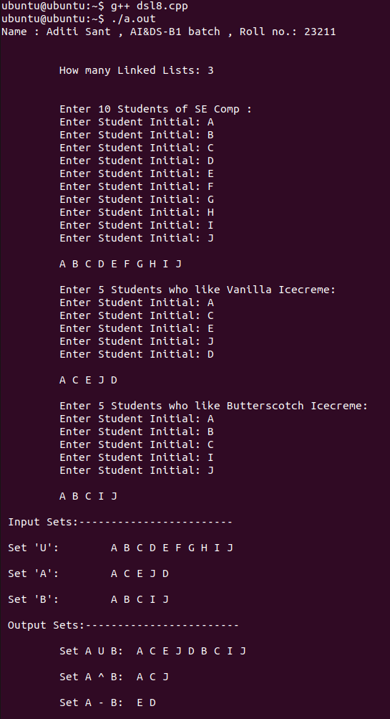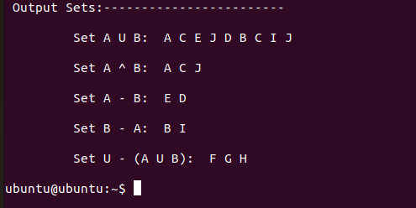**OUTPUT**